***Symbol LS3578ER Rugged Scanner***

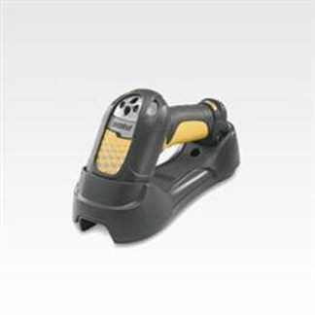

**$1,485.00**

**Features and Benefits**

**Wide working range**   
Allows workers to scan items at 4 in (10 cm) to 45 ft (13.7 m).   
  
**Bluetooth-enabled cordless scanning**   
Ensures secure wireless data transmission.   
  
**Rugged design**   
Withstands multiple 6.5 ft (2 m) drops to concrete, lessening downtime from accidental drops.   
  
**Bright LED and beeper with adjustable volume**   
Makes decode feedback clearly visible and audible to users, even in noisy environments.   
  
**Multi-point communication**   
Allows use of up to three scanners with a single cradle.   
  
**Bright 650-nm laser aiming dot**   
Delivers clearly visible line for more accurate scanning.   
  
**Advanced data formatting**   
Eliminates costly modifications to the host software.   
  
**Batch mode operation**   
Increases application design flexibility.   
  
**Remote scanner management**   
Enables you to discover, provision and upgrade devices from a central remote location.